**Screenshots of implementation**

**Enabling SSH on routers/switches**

**Enabling privileged mode passwords and DNS as shown  
  
Showing only one here implemented on all routers/switches**

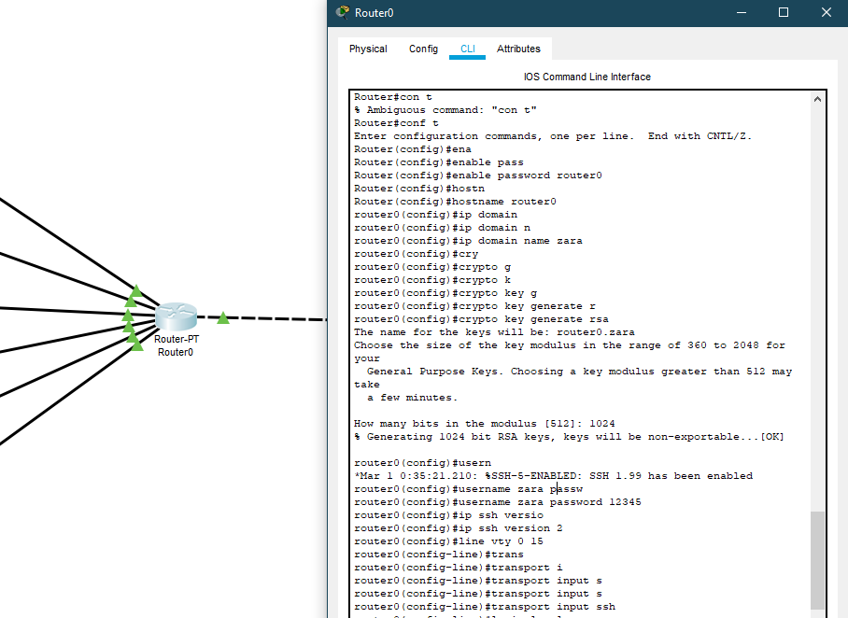

Accessing router0 via SSH:  
privileged mode password and ssh encryption done.

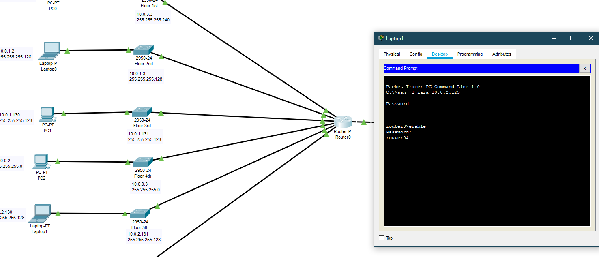

Switch 1 SSH

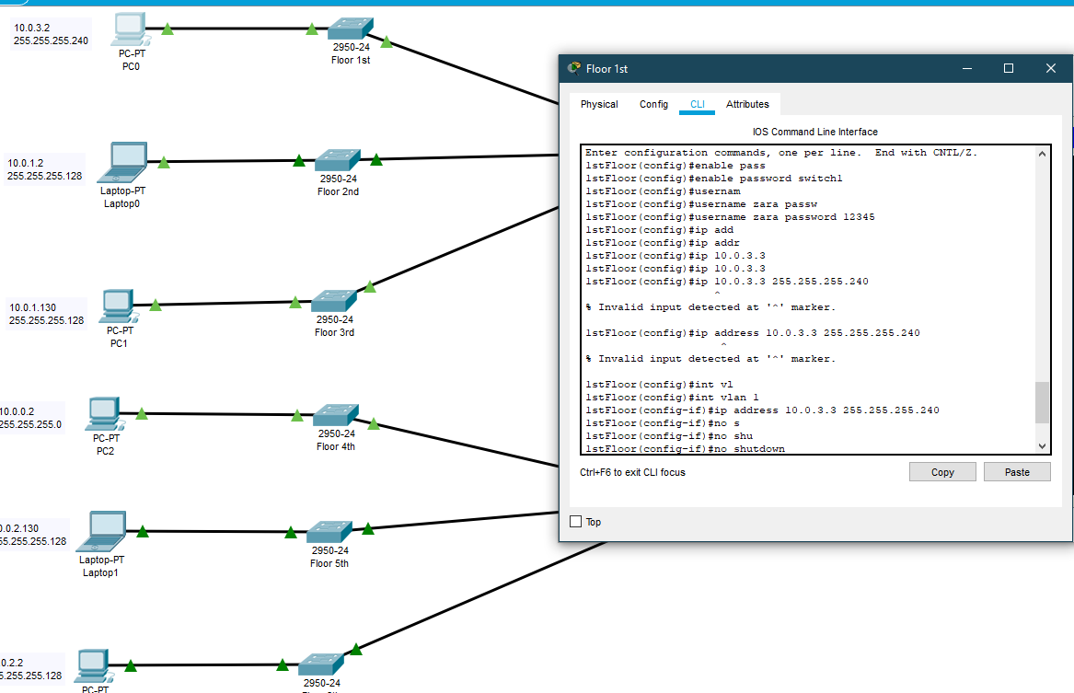

Accessing switch1/1stfloor via PC0 (ssh)

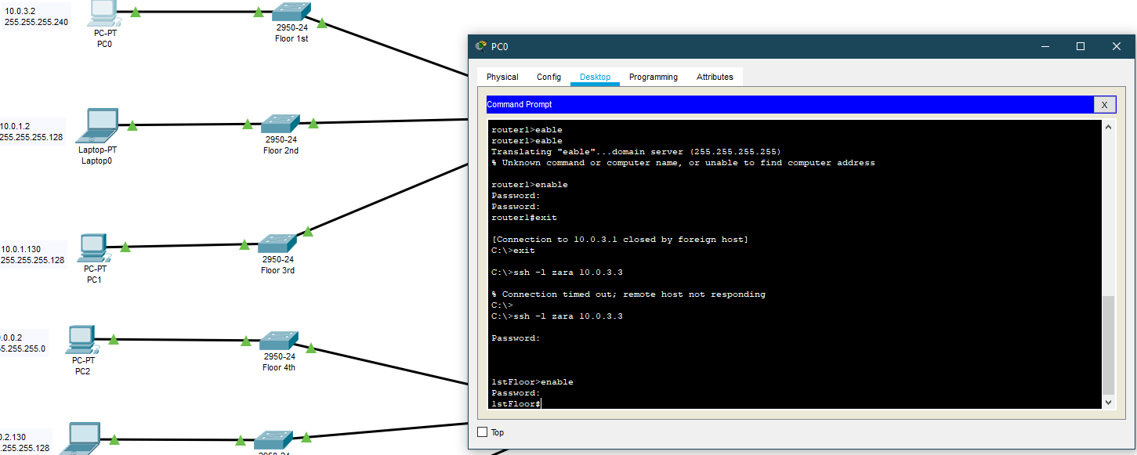

**DNS working fine as well:**

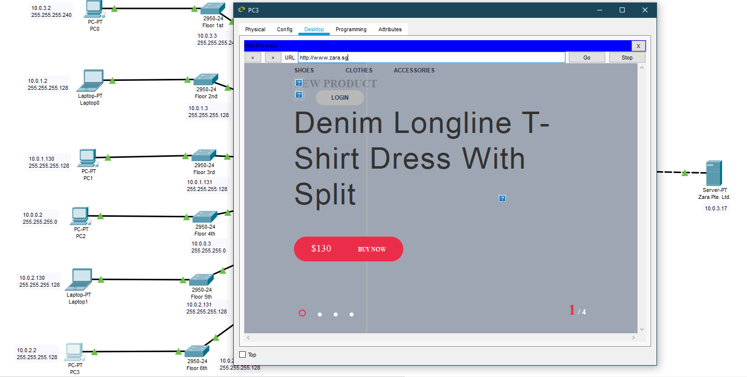

ZARA Pte. Ltd.  
Webpage

  
  
  
**I don’t know why Zara Pte. Ltd. server is not loading the .css and javascript(.js) files properly but the DNS is working fine (all webpage files included in rar)**